**PRE-LAB REPORT**

**Experiment No :** 05

**Name of The Experiment : Study of the frequency response of FET amplifier**

**Circuit Diagram :**

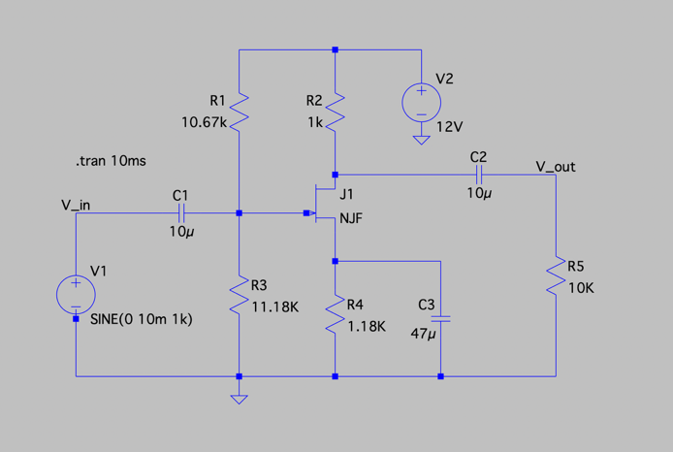

**Input & Output :**

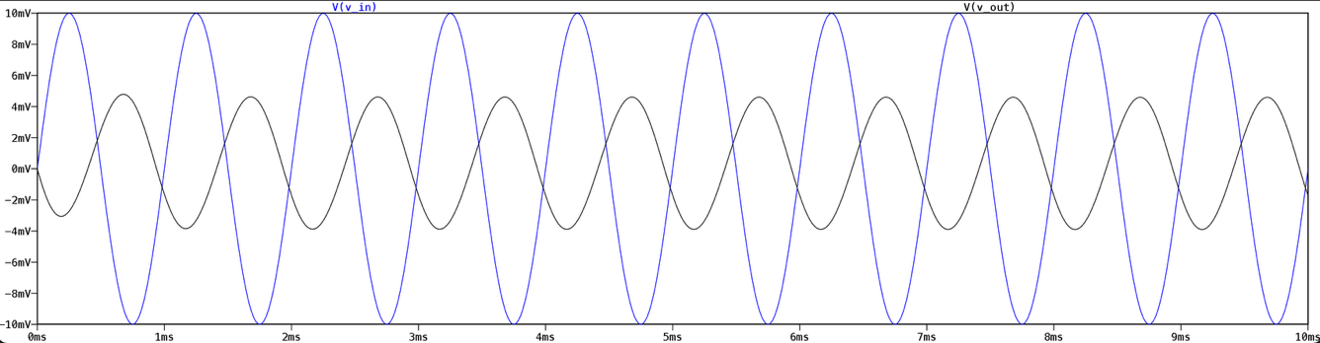

**Summary:**

This experiment demonstrates the frequency response of a single-stage RC-coupled FET amplifier using a BFW10 JFET. A 10 mV sine wave input was applied, and the output voltage was measured across a range of input frequencies. The gain was calculated in decibels (dB) and plotted against frequency to observe the amplifier’s behavior. From the graph, the lower and upper cutoff frequencies (fL and fH) were identified, and the bandwidth (BW = fH – fL) was determined, confirming the expected frequency-dependent performance of the FET amplifier.